Title: Top-down social modulation of interpersonal observation-execution

Running head: Social modulation of motor contagion

James W. Roberts*, Simon J. Bennett, &, Spencer J. Hayes

Brain and Behaviour Laboratory,
Liverpool John Moores University, Liverpool, UK

*Corresponding author
Brain and Behaviour Laboratory, Faculty of Science, Liverpool John Moores University, Byrom Street, Liverpool, L3 3AF, UK
Tel: +44 (0) 151 904 6237, Fax: +44 (0) 151 904 6284
J.W.Roberts@2006.ljmu.ac.uk

The final publication is available at Springer via http://dx.doi.org/[DOI: 10.1007/s00426-015-0666-9]
Abstract
Cyclical upper-limb movement can involuntarily deviate from its primary movement axis when the performer concurrently observes incongruent biological motion (i.e., interpersonal observation-execution). The current study examined the social modulation of such involuntary motor interference using a protocol that reflected everyday social interactions encountered in a naturalistic social setting. Eighteen participants executed cyclical horizontal arm movements during the observation of horizontal (congruent) or curvilinear (incongruent) biological motion. Both prior to, and during the interpersonal observation-execution task, participants also received a series of social words designed to prime a pro-social or anti-social attitude. The results showed greater orthogonal movement deviation, and thus interference, for the curvilinear compared to horizontal stimuli. Importantly, and opposite to most of the previous findings from work on automatic imitation and mimicry, there was a greater interference effect for the anti-social compared to pro-social prime condition. These findings demonstrate the importance of interpreting the context of social primes, and strongly support predictions of a comparison between the prime construct and the self-concept/-schema and the top-down response modulation of social incentives.

Keywords:
Motor contagion, Top-down, Social modulation, Interpersonal
Introduction
It is well known that perception and action share a specific common representational domain (Prinz, 1997; Hommel, Müsseler, Aschersleben, & Prinz, 2001). The neural substrate underpinning this coupling is suggested (Cattaneo, Sandrini, & Schwarzbach, 2010; Kilner, Neal, Weiskopf, Friston, & Frith, 2009) to be the human mirror system (inferior frontal gyrus, premotor cortex, inferior parietal lobule), which supports the imitation of actions (Iacoboni et al., 1999) and the acquisition of motor skills via observation (Cross, Kraemer, Hamilton, Kelley, & Grafton, 2009). In addition to representing motor actions, imitation is a very important mechanism for developing of social rapport (Chartrand & Bargh, 1999) and feelings of affiliation (Lakin & Chartrand, 2003; van Baaren, Janssen, Chartrand, & Dijksterhuis, 2009).
Using the common behavioural method, automatic imitation, it is generally found that characteristics present in an observed biological action interfere with the sensorimotor processes engaged by an observer. For example, reaction time associated with a pre-specified motor response (open hand) is slower having observed an incongruent (closed hand) motor prime (Stürmer, Aschersleben, & Prinz, 2000). This slowed response is caused by motor interference, and has been referred to as motor contagion (Blakemore & Frith, 2005) associated with the co-activation of conflicting internal sensorimotor representations. Co-activation is suggested to be underpinned by automatic bottom-up sensorimotor processes (e.g., direct-matching; Rizzolatti, Fogassi, & Gallese, 2001) involving the direct stimulation of sensory receptors that operate in the absence of any intermediary conceptual (top-down) contribution (Teufel, Fletcher, & Davis, 2010).
There is, however, evidence indicating that bottom-up processes engaged during automatic imitation, and mimicry, are modulated by top-down processes associated with social cognition (Cook & Bird, 2011; Hogeveen & Obhi, 2011; Leighton, Bird, Orsini, & Heyes, 2010, Wang, Newport, & Hamilton, 2011). For example, using a scrambled-sentence task to prime social attitudes prior to the observation of a static hand posture, Leighton et al. (2010) found that automatic imitation was enhanced (i.e., increased congruent-incongruent reaction time differences) following a pro-social prime (“together”), and attenuated (i.e., decreased congruent-incongruent reaction time differences) following an anti-social prime (“independent”). Moreover, to ensure contagion was associated with sensorimotor processes underpinning automatic mimicry, as opposed to spatial compatibility, the task environment was decoupled such that movement responses (hand placed in a horizontal orientation) of the observer were orthogonal to the stimulus postures (hand placed in a vertical orientation) viewed on the monitor (Cook & Bird, 2011). With such control in mind, it was suggested that social primes down-regulate (pro-) or up-regulate (anti-) the top-down processes responsible for modulating automatic imitation. Such effects of social primes are the basis of the social top-down response modulation (STORM) model (Wang & Hamilton, 2012), where automatic imitation and mimicry is suggested to be a product of strategic behaviour that inhibits or enhances a motor response based on a social setting. For instance, it was reported that mimicry was enhanced (shorter reaction time) when participants were primed with a model that showed direct eye gaze, compared to averted eye gaze (Wang et al., 2011). It was reasoned that in the former condition, the prime (direct gaze) created a social setting that triggered mimicry to enhance social affiliation (Wang & Hamilton, 2012).
Building upon behavioural work that examined mimicry in patients with lesions (Spengler, von Cramon, & Brass, 2010), as well as a study on the effects of theory of mind training (Santiesteban et al., 2012), both of which indicated an association between the mentalising regions in frontal cortex and the mirror system, Wang and colleagues (Wang, Ramsey, & Hamilton, 2011) investigated the processing of primes during mimicry using dynamic causal modelling. The analysis indicated an interaction between eye-gaze direction and interconnections between medial prefrontal cortex (mPFC), superior temporal sulcus (STS) and mirror system. Medial prefrontal cortex is thought to provide top-down control (Wang & Hamilton, 2014) of input to superior temporal sulcus and thereby the processing of biological motion (Allison, Puce, & McCarthy, 2000), as well as the mirror system, where direct visuomotor mapping of an the observed biological action is implemented during mimicry and automatic imitation (e.g., Cook & Bird, 2011; Leighton et al., 2010; Obhi, Hogeveen, & Pascual-Leone, 2011; Wang et al., 2011).
While not intending to refute previous findings of social modulation in automatic imitation studies, it is relevant to note that the stimuli presented typically involved static images (Leighton et al., 2010) or discrete manual actions (Wang et al., 2011). Therefore, visuomotor mapping in such contexts occurred from observing human actions without the presence of continuous biological motion, and with that, the interpersonal connectedness of naturalistic social settings. Moreover, visuomotor mapping was inferred by measuring changes in reaction time, which does not directly relate to the biological motion properties of the observed movement. It is therefore not clear from these automatic imitation protocols if social top-down processes modulated imitation behaviour by regulating goal-directed processes associated with the action goal (final open hand posture) and/or lower-level visuomotor processes associated with mapping biological motion kinematics (hand opening motion).
To this end, we examined top-down social modulation of biological motion kinematics in the present study using an interpersonal observation-execution protocol. In addition to examining biological kinematics, this type of protocol allows the measurement of involuntary motor interference over a time span (̴ 30 seconds) that is similar to naturalistic social settings (Chartrand & Bargh, 1999). Like automatic imitation and mimicry, motor interference during interpersonal observation-execution is linked to superior temporal sulcus and the mirror system (Blakemore & Frith, 2005; Press, Cook, Blakemore, & Kilner, 2011), both of which are implicated in processing biological motion kinematics. Therefore, following a pro-social (e.g., together) or anti-social (e.g., independent) prime word (Hogeveen & Obhi, 2011; Obhi et al., 2011), participants executed cyclical horizontal arm movements across the mid-line of the body while simultaneously observing a horizontal or curvilinear model displaying biological motion kinematics. The horizontal stimulus displays a movement with a congruent horizontal trajectory and congruent spatial end-points. To isolate motor interference to the biological motion kinematics we used an incongruent model that displayed a curvilinear trajectory (Roberts, Hayes, Uji, & Bennett, 2014). Therefore, and unlike a vertical trajectory previously adopted (e.g., Kilner et al., 2003), the curvilinear model had the same (congruent) spatial end-points as the horizontal model, but importantly, the movement trajectory was incongruent. Controlling the presence of spatial end-points (Stanley et al., 2007) allows any resulting difference in the magnitude of motor interference to be ascribed to the processing of the incongruent biological motion movement trajectory, separate from the spatial end-points (Roberts et al., 2014). Finally, if social primes modulate the processing of biological motion kinematics, we expected the greatest motor contagion following pro-social primes compared to anti-social primes.

Method
Participants
Data was recorded from eighteen participants (aged between 18 to 21 years). All had normal or corrected-to-normal vision and gave written informed consent prior to taking part. The experiment was designed in accordance with the Declaration of Helsinki and was approved by the local ethics committee of the host university.

Stimuli
The visual stimuli were back-projected (Hitachi CP-X345) on a flat white screen (2.74 x 3.66 m) at a viewing distance of 1.9 m. The stimuli were video clips edited using Adobe Premier CS5 software, which were subsequently presented using the COGENT toolbox implemented in MATLAB (Mathworks Inc). The stimuli consisted of a social prime located in each of the four corners of the screen (see Fig. 1). The social primes were a select number of pro-social (alliance, cooperate, friend, group, integrate, social, team, together) or anti-social (alone, independent, individuality, mine, self, singular, solitary, solo) words adapted from Hogeveen & Obhi, 2011). In conjunction with the onset of the social prime, there was a static image of a human model located at screen centre. This provided participants the opportunity to process the social prime prior to stimulus movement onset. Following a 3 s delay, the model began to move the right arm for 30 s on a horizontal or curvilinear trajectory. Scaling of the model image was applied in order that 400 mm horizontal displacement in the recorded data corresponded to 400 mm horizontal displacement on the projection screen. Notably, the curvilinear movement had a horizontal amplitude of 400 mm and vertical amplitude of 200 mm (from centre to the upper vertex). Thus, the curvilinear movement end-points aligned with those of the horizontal stimulus. The movements were well practised by the models in order that the required movement amplitude and segment frequency of 1 Hz could be reliably achieved. Finally, there was a control condition in which a single red dot was presented at screen-centre for the duration of the trial. Participants were instructed to fixate on the stationary stimulus while moving their arm at 400 mm horizontal amplitude. The control condition determined if there was any attention or muscular fatigue effects of performing continuous horizontal arm movements across a series of trials. In addition, the control condition enabled us to determine whether any differences between the experimental stimulus conditions were a result of motor facilitation or interference. In the case of motor facilitation, reduced movement deviation may be evident in the horizontal compared to the control condition because the horizontal model acts as a predictable external dynamic reference that facilitates feedforward and feedback processing during observation-execution (Miall, Imamizu, & Miyauchi, 2000). For motor interference, greater movement deviation may be evident in the curvilinear compared to the control condition due to increased motor resonance caused by the incongruent movement (Kilner et al., 2003).

Insert Fig. 1 about here

Task and Procedure
Initially, each participant performed two practice trials that required horizontal arm movements in the presence (i.e., with guidance) of stationary end-point targets located 400 mm apart in the horizontal axis, and auditory tones presented by a metronome. Participants were instructed to time their movement so that the end-points, and thus reversals, coincided with the end-point targets and auditory tones. Following the two practice trials, we removed the end-point targets and auditory metronome, and participants performed the same horizontal arm movements when fixating on a stationary stimulus (control condition) or in-time with a cyclical horizontal or curvilinear moving stimulus (experimental conditions). In addition, participants had to also read a word presented in each of the four corners of the screen, and after each trial, write the word on a data sheet supplied by the experimenter. To ensure participants were unaware of the purpose of the social manipulation, participants were informed that it was designed to clarify whether they followed the stimulus on the screen.
There were two trials for each moving stimulus for both pro-social and anti-social prime conditions. The trial presentation was pseudo-randomly ordered with the caveat that no trial could be repeated consecutively. For a single participant, the pro-social prime was assigned to one model, whilst the anti-social was assigned to the other model. To ensure there were no confounding influences of the model, the assignment of the social prime to a model stimulus was counter-balanced across participants. Both models followed the same pattern of movement within the horizontal and curvilinear movement direction (see Fig. 2). Finally, the control trials were presented at the start and end so as to determine if there were any attentional and fatigue effects associated with performing continuous cyclical movements.

Data collection and analysis
The position of an active infrared sensor, attached to the tip of the index finger was recorded at 200 Hz using a 3D Investigator Motion Capture System (Northern Digital Inc., Ontario, Canada). Following data acquisition, the first and last 5 s of data recording were discarded in order to minimize asynchrony around movement onset and potential attentional and fatigue effects. The remaining position data were then low-pass filtered at 10 Hz using an autoregressive filter implemented in MATLAB. The same routine next determined individual movement segments by identifying reversals in sensor position of the dominant movement axis (i.e., x-axis; horizontal). As an indicator of contagion, the standard deviation of fingertip position within the orthogonal movement axis was extracted (i.e., y-axis; vertical) for each movement segment. The average was then calculated across the movement segments of individual trials for each participant.
In addition, as a measure of mapping the stimulus-motion properties, we calculated the mean orthogonal position across consecutive bins of 10% (10-100%) of the primary movement axis (i.e., x-axis; horizontal). This way, any contagion effects could be attributed to the unfolding trajectory of the observed stimuli (Dijkerman & Smit, 2007; Griffiths & Tipper, 2009; 2012; Hardwick & Edwards, 2011). With respect to the observation of an incongruent curvilinear stimulus (Fig. 2), we would anticipate the mapping of stimulus-motion properties to exhibit an initially low orthogonal position which would subsequently increase near the mid-portion of the trajectory before finally decreasing toward the end of the movement.

Insert Fig. 2 about here

For statistical analysis, we first conducted a 2 trial number (start, end) x 2 prime (pro-social, anti-social) repeated-measures ANOVA to compare the effects in control trials on average deviation data. We then submitted average deviation data from the experimental conditions to a 3 stimuli (horizontal, curvilinear, control) x 2 prime (pro-social, anti-social) repeated-measures ANOVA. The data on mean orthogonal position as proportions of the entire movement trajectory were analysed using a 3 stimuli (horizontal, curvilinear, control) x 2 prime (pro-social, anti-social) x 10 position (10-100%) repeated-measures ANOVA. Where appropriate, violation of the Sphericity assumption was corrected using the Greenhouse-Geisser method. Significant effects were decomposed using Tukey HSD post hoc procedure. Significance was declared at p < .05.

Results
The written feedback from the identification of the social words indicated that participants had successfully adhered to the social priming task (M = 98.68%; SE = .13). Though participants predominantly recognised the social origin of these words (10 out of the 18 participants), none were able to infer any influence toward the interpersonal observation-execution task.

Movement deviation
For the comparison of control trials, there was no significant main effect of trial number, F(1, 14) = .002, p > .05, partial ƞ² = .00. Thus, there were no attentional or muscular fatigue effects introduced by performing the 30-second duration experimental trials.
Moreover, there was no significant main effect of prime, F(1, 14) = 1.27, p > .05, partial ƞ² = .08, nor a significant interaction between trial number and prime, F(1, 14) = 1.24, p > .05, partial ƞ² = .08.
For the analysis of experimental trials, ANOVA revealed a significant main effect of stimuli, F(2, 34) = 9.96, p < .05, partial ƞ² = .37. As expected, the curvilinear condition had increased movement deviation compared to the horizontal and control conditions (p < .05), whilst there was no significant difference across horizontal and control conditions (p > .05). There was no significant main effect of prime, F(1,17) = 1.99, p > .05, partial ƞ² = .11, although there was a significant interaction involving stimuli and prime, F(2, 34) = 3.73, p
< .05, partial ƞ² = .18 (see Fig. 3). Post hoc analysis indicated that in the curvilinear condition, there was significantly larger deviation for the anti-social compared to the pro-social prime (p < .05, partial ƞ² = .21), although there were no significant differences within the control (p > .05, partial ƞ² = .10) and horizontal stimulus conditions (p > .05, partial ƞ² = .04).

Insert Fig. 3 about here

Movement trajectory
In order to assess whether contagion was attributed to the precise stimulus-motion properties, we assessed the movement trajectories by calculating mean orthogonal position at the moment participants reached 10% intervals of their horizontal movement direction (for similar procedures, see Griffiths & Tipper, 2012). ANOVA revealed a significant main effect of stimuli, F(2, 34) = 16.73, p < .05, partial ƞ² = .50, and position, F(9, 153) = 21.27, p < .05, partial ƞ² = .55. However, these effects were superseded by significant interactions of stimuli x position, F(18, 306) = 17.17, p < .05, partial ƞ² = .50, and stimuli x prime x position, F(18, 306) = 3.38, p < .05, partial ƞ² = .17 (see Fig. 4). The three-way interaction revealed the increased orthogonal movement for anti-social primes in the curvilinear condition was due to the observed stimulus-motion properties as the anti-social primes achieved a significantly higher orthogonal position than pro-social primes only during the mid-portions of the movement trajectory (20%: p < .05, partial ƞ² = .13; 30-80%: ps < .05, partial ƞ² = .14). Further, there were no significant differences between social primes at any of the positions for the horizontal and control conditions (p >.05).

Insert Fig. 4 about here

Discussion
Previous work has demonstrated that automatic imitation (Leighton et al., 2010; Cook & Bird, 2011; Wang et al., 2011) and naturalistic behavioural mimicry (van Baaren, Maddux, Chartrand, & van Knippenberg, 2003) is enhanced following a pro-social prime compared to an anti-social prime. In these studies, participants typically responded while observing static images or short videos of biological actions, and as such it is not clear whether the prime modulates processing of biological motion kinematics (hand motion) and/or the action goal (final open hand posture). In the present experiment, we used an interpersonal observation-execution task so that involuntary motor interference was investigated over an extended time period, which is akin to naturalistic interpersonal communication. We used a novel curvilinear model that had the same (congruent) spatial end-points as the horizontal model, but an incongruent movement trajectory. Controlling the presence of spatial end-points allowed us to attribute motor interference to the processing of biological motion kinematics as opposed to the spatial end-points (Roberts et al., 2014).
Consistent with previous work (Kilner et al., 2003; Stanley, Gowen, & Miall, 2007), the current findings indicated greater movement deviation, and thus increased motor contagion, when observing the curvilinear stimulus (incongruent movement, congruent end-goals) compared to the horizontal (congruent) stimulus and control conditions. The contagion effects were specific to the unfolding stimulus-motion properties of the curvilinear model as indicated by an increase in the orthogonal position at the mid-portion of the movement trajectory. There was, however, no reduction in movement deviation when observing the horizontal model compared to control condition indicating the predictable external reference did not facilitate observation-execution through feedforward and feedback processes (Maill et al., 2000). Moreover, the finding of no behavioural differences between the first and final control trials, confirms that the effect of stimuli was independent of any changes in attention, or motor fatigue, whilst performing the upper-limb cyclical task. Therefore, we suggest that motor contagion was associated with processing biological motion kinematics in the movement trajectory. This interpretation is consistent with previous data (Roberts et al., 2014) that showed greater deviation when observing the curvilinear stimuli, compared to the horizontal stimuli. Like the present experiment, this manipulation kept similar spatial end-point locations in both conditions allowing us to isolate contagion effects to the movement trajectory, as opposed to the end-state goal (Stanley et al., 2007).
In addition to confirming a general motor contagion effect in the curvilinear condition, we found that this was influenced by the pro-social or anti-social nature of the prime. Contrary to our initial expectation, there was greater contagion when participants were primed with anti-social words, thus indicating social modulation of processing biological motion kinematics during interpersonal observation-execution. Such a finding is also opposite to the social top-down modulation effects reported in most other work on automatic imitation (Cook & Bird, 2011; Leighton et al., 2010) and mimicry (Wang et al., 2011). In said studies, increased mimicry effects following pro-social priming have been suggested to result from the activation of social motives designed to affiliate with another individual (Lakin & Chartrand, 2003; Wang & Hamilton, 2012) and/or the activation of a prosocial self-schema eliciting interpersonal behaviour designed to assimilate (Wang & Hamilton, 2013). Specifically, the aforementioned processes are suggested to generate top-down control signals that regulate the lower-level visuomotor mechanisms (mirror system) controlling automatic imitation and mimicry as shown using TMS (Hogeveen & Obhi, 2012; Obhi et al., 2011) and fMRI (Wang & Hamilton, 2014; Wang, Ramsey et al., 2011).
Why, then, did we find increased social modulation following priming by anti-social words? We do not believe this is simply due to differences between the interpersonal observation-execution and automatic imitation tasks. Rather, we suggest the interpretation of the prime is important in determining whether or not there is increased imitation or mimicry. For instance, in the work of Wang and Hamilton (2013), the mimicry effects were specific to the anti-social prime from a third-person perspective (e.g., “Joe cruelly bullied Stephanie about her weight problem”) as opposed to a first-person perspective (e.g., “I cruelly bullied Stephanie about her weight problem”). It was suggested the third-person anti-social sentences may have driven a self-comparison process that primed a pro-social self-concept, and subsequent mimicry behaviour. This interpretation draws on evidence of contrast prime-to-behaviour effects when presented with an exemplar prime that conflicts with the active self-concept (Dijksterhuis et al., 1998). The active self-concept can be explained by a transient representation of the self as determined by perceived prime constructs (Wheeler, DeMarree,
& Petty, 2007). For example, upon receiving an exemplar prime deemed incongruent to one self (e.g., ‘Einstein’); the individual primes a behaviour that is in contrast to the prime itself (e.g., stupidity). Alternatively, when presented with a stereotypical prime (e.g., ‘professor’) the individual assimilates with the primed concept (e.g., intelligence). These effects are associated with the activation of anterior medial prefrontal cortex (Wang & Hamilton, 2014), which controls top-down responses during mimicry (Brass, Derrfuss, & von Cramon, 2005; Wang et al., 2011). Here, then, the nature of the interpersonal observation-execution task may have created a social context where the participant associated the prime with the observed stimulus model. In doing so, a pro-social prime would not be unlike the participant, whilst an anti-social prime would conflict with, and prime, the active self-concept, which generated greater contagion. It is noteworthy that the predictions surrounding these processes feature an up-regulation or increase in contagion when presented an anti-social prime, whilst a pro-social prime would be relatively similar to control levels (i.e., no prime; or neutral prime). Future research would benefit from the inclusion of such a control condition in order to experimentally determine facilitatory and/or inhibitory processes associated with the pro- and anti-social prime conditions.
It has also been suggested that anti-social primes may increase the desire to restore social harmony, which leads to increased mimicry as a means to affiliate with a partner (Wang & Hamilton, 2013). This type of priming is consistent with social top-down response processes (Wang & Hamilton, 2012) that modulate motor contagion based on the affiliation goal. For example, it has been shown that failed attempts to affiliate (Lakin & Chartrand, 2003) and exclusion from group-based tasks (Lakin, Chartrand, & Arkin, 2008; Over & Carpenter, 2009) increases naturalistic behavioural mimicry. This suggests that individuals adopt mimicry behaviour in order to achieve a social incentive (e.g., “affiliate with the model stimulus”), particularly when the goal is at risk (e.g., “the model stimulus is not interested”). With respect to the current study, it is likely that the motivation to affiliate was enhanced when participants were initially asked to synchronise their movements with the observed model stimulus. The notion of enhancing affiliation through interpersonal coordination has been shown via increasing pro-social interdependent cognitive processing during the synchronisation of upper-limb movements between dyadic pairs (Miles, Nind, Henderson, & Macrae, 2010). Therefore, in an interpersonal context, the social modulation account would suggest an anti-social prime had an additive impact on the affiliation goal, and a greater motor contagion based on an increased desire to affiliate.
The aforementioned self-contrast and goal perspectives suggest increased contagion is based on higher-level interpretative processes regulating the lower-level sensorimotor mechanisms via input and/or output modulation. Although we do not have data to specify the direction of these interpretative processes, it is noteworthy that visual attention to stimuli is also heightened during social-cultural environments (Nisbett, Peng, Choi, & Norenzayan, 2001; van Baaren et al., 2009). For example, visual attention to environmental stimuli may operate in an independent manner whereby an observer has the tendency to ignore mannerisms leading to reductions in mimicry (van Baaren et al., 2003). Alternatively, if attention is context dependent, the goal of social interaction is to develop behavioural assimilation which enhances mimicry because more mannerisms are noticed. It is therefore possible that following an anti-social prime in the present study increased contagion was underpinned by heightened attention to the observation and processing of biological motion kinematics. This form of top-down control is consistent with an input modulation (Heyes, 2011; Longo, Kosobud, & Bertenthal, 2008) view of automatic imitation where modulation impacts the activation, or development, of sensorimotor representations via the orientation of visual attention. Here, then, top-down control would operate at the perceptual level through the superior temporal sulcus (associated with coding biological motion), and fronto-parietal mirror network (associated with stimulus-response mapping) (Obhi et al., 2011; Teufel et al., 2010; Wang & Hamilton, 2012).
In summary, we found incongruent curvilinear movement stimuli led to greater orthogonal movement deviation than horizontal movement stimuli, and that these differences were increased by an anti-social prime compared to a pro-social prime. These modulatory effects were related to the lower-level stimulus-motion properties with executed orthogonal deviation following a similar trace to the observed curvilinear movement trajectory. We suggest the interpersonal nature of the task may have elicited a third-person prime perspective, which drew comparisons between the prime and self (Wang & Hamilton, 2013), and/or the affiliation goal that was further enhanced when presented with an anti-social prime, deemed a threat toward the interpersonal encounter (Wang & Hamilton, 2012). Thus, the direction of mimicry-/contagion-like effects is specific to the self-comparison process, and the desire to affiliate with the model stimulus.
Acknowledgements
We would like to thank David Broadbent and Chris Dutoy for their help on designing the model stimuli.
References
Allison, T., Puce, A. & McCarthy, G. (2000). Social perception from visual cues: role of the STS region. Trends in Cognitive Sciences, 4, 267-278. doi: 10.1016/S1364-6613(00)01501-1

Blakemore, S. J. & Frith, C. (2005). The role of motor contagion in the prediction of action. Neuropsychologia, 43, 260-267. doi: 10.1016/j.neuropsychologia.2004.11.012

Brass, M., Derrfuss, J., & von Cramon, D. Y. (2005). The inhibition of imitative and overlearned responses: a functional double dissociation. Neuropsychologia, 43, 89-98. Doi: 10.1016/j.neuropsychologia.2004.06.018

Cattaneo, L., Sandrini, M., & Schwarzbach, J. (2010). State-dependent TMS reveals a hierarchical representation of observed acts in the temporal, parietal, and premotor cortices. Cerebral Cortex, 20, 2252-2258. doi: 10.1093/cercor/bhp291

Chartrand, T. L. & Bargh, J. A. (1999). The chameleon effect: the perception-behavior link and social interaction. Journal of Personality and Social Psychology, 76, 893-910. doi: 10.1037//0022-3514.76.6.893

Cook, J. & Bird, G. Social attitudes differentially modulate imitation in adolescents and adults. (2011). Experimental Brain Research, 211, 601-612. doi: 10.1007/s00221-011-2584-4

Cross, E. S., Kraemer, D. J. M., Hamilton, A. F. de C., Kelley. W. M., & Grafton, S. T. (2009). Sensitivity of the action observation network to physical and observational learning. Cerebral Cortex, 19, 315-326. doi: 10.1093/cercor/bhn083

Dijkerman, H. C. & Smit, M. C. (2007). Interference of grasping observation during prehension, a behavioural study. Experimental Brain Research, 176, 387-396. doi: 10.1007/s00221-006-0627-z

Dijksterhuis, A., Spears, R., Postmes, T., Stapel, D., Koomen, W., et al., (1998). Seeing one thing and doing another: Contrast effects in automatic behaviour. Journal of Personality and Social Psychology, 75, 862-871. doi: 10.1037//0022-3514.75.4.862

Griffths, D. & Tipper, S. P. (2009). Priming reach trajectory when observing actions: Hand – centred effects. Quarterly Journal of Experimental Psychology, 62, 2450-2470. doi: 10.1080/17470210903103059

Griffiths, D. & Tipper, S. P. (2012). When far becomes near: Shared environments activate action simulation. Quarterly Journal of Experimental Psychology, 65, 1241-1249. doi: 10.1080/17470218.2012.688978

Hardwick, R. M. & Edwards, M. G. (2011). Observed reach trajectory influences executed reach kinematics in prehension. Quarterly Journal of Experimental Psychology, 64, 1082-1093. doi: 10.1080/17470218.2010.538068

Heyes, C. M. (2011). Automatic imitation. Psychological Bulletin, 137, 463-483. doi: 10.1037/a0022288

Hogeveen, J. & Obhi, S. S. (2011). Altogether now: activating interdependent self-construal induces hypermotor resonance. Cognitive Neuroscience, 2, 74-82. doi: 10.1080/17588928.2010.533164

Hommel, B., Müsseler, J., Aschersleben, G., & Prinz, W. (2001). The Theory of Event Coding (TEC): A framework for perception and action planning. Behavioral and Brain Sciences, 24, 849-878. doi: 10.1017/S0140525X01000103

Iacoboni, M., Woods, R. P., Brass, M., Bekkering, H., Mazziotta, J. C., & Rizzolatti, G. (1999). Cortical mechanisms of human imitation. Science, 286, 2526-2568. doi: 10.1126/science.286.5449.2526

Kilner, J. M., Neal, A., Weiskopf, N., Friston, K. J., & Frith, C. D. (2009). Evidence of mirror neurons in human inferior frontal gyrus. The Journal of Neuroscience, 29, 10153-10159. doi: 10.1523/JNEUROSCI.2668-09.2009

Kilner, J. M., Paulignan, Y., & Blakemore, S. J. (2003). An interference effect of observed biological movement on action. Current Biology, 13, 522-525. doi: 10.1080/17470910701428190

Lakin, J. L. & Chartrand, T. L. (2003). Using nonconscious behavioural mimicry to create affiliation and rapport. Psychological Science, 14, 334-339. doi: 10.1111/1467-9280.14481

Lakin, J. L., Chartrand, T. L., & Arkin, R. M. (2008). I am just too like you: nonconscious mimicry as an automatic behavioural response to social exclusion. Psychological Science, 19, 816-822. doi: 10.1111/j.1467-9280.2008.02162.x

Leighton, J., Bird, G., Orsini, C., & Heyes, C. (2010). Social attitudes modulate automatic imitation. Journal of Experimental Social Psychology, 46, 905-910. doi: 10.1016/j.jesp.2010.07.001

Longo, M. R., Kosobud, A., & Bertenthal, B. I. (2008). Automatic imitation of biomechanically possible and impossible action: effects of priming movements versus goals. Journal of Experimental Psychology: Human Perception and Performance, 34, 489-501. doi: 10.1037/0096-1523.34.2.489

Miall, R. C., Imamizu, H., & Miyauchi, S. (2000). Activation of the cerebellum in co-ordinated eye and hand tracking movements: an fMRI study. Experimental Brain Research, 135, 22-33. doi: 10.1007/s002210000491

Miles, L. K., Nind, L. K., Henderson, Z., & Macrae, N. (2010). Moving memories: behavioural synchrony and memory for self and others. Journal of Experiment Social Psychology, 46, 457-460. doi: 10.1016/j.jesp.2009.12.006

Nisbett, R. E., Peng, K., Choi, I., & Norenzayan, A. (2001). Culture and systems of thought: holistic versus analytic cognition. Psychological Review, 108, 291-310. doi: 10.1037/0033-295X.108.2.291

Obhi, S. S., Hogeveen, J., & Pascual-Leone, A. (2011). Resonating with others: the effects of self-construal type on motor cortical output. The Journal of Neuroscience, 31, 14531-14535. doi: 10.1523/JNEUROSCI.3186-11.2011

Over, H. & Carpenter, M. (2009). Priming third-party ostracism increases affiliative imitation in children. Developmental Science, 12, F1-F8. doi: 10.1111/j.1467-7687.2008.00820.x

Press, C., Cook, J., Blakemore, S. J., & Kilner, J. (2011). Dynamic modulation of human motor activity when observing actions. The Journal of Neuroscience, 31, 2792-2800. doi: 10.1523/JNEUROSCI.1595-10.2011

Prinz, W. (1997). Perception and action planning. European Journal of Cognitive Psychology, 9, 129-154. doi: 10.1080/713752551

Rizzolatti, G., Fogassi, L., & Gallese, V. (2001). Neurophysiological mechanisms underlying the understanding and imitation of action. Nature Reviews Neuroscience, 2, 661-670. doi: 10.1038/35090060

Roberts, J. W., Hayes, S. J., Uji, M., & Bennett, S. J. (2014). Motor Contagion: dissociating the effects of movement trajectory and end-state goals. Psychological Research. doi: 10.1007/s00426-014-0589-x

Santiesteban, I., White, S., Cook, J., Gilbert, S. J., Heyes, C., & Bird, G. (2012). Training social cognition: from imitation to theory of mind. Cognition, 122, 228-235.10.1016/j.cognition.2011.11.004

Spengler, S., von Cramon, D. Y., & Brass, M. (2010). Resisting motor mimicry: control of imitation involves processes central to social cognition in patients with frontal and temporo-parietal lesions. Social Neuroscience, 5, 401-416. doi: 10.1080/17470911003687905

Stanley, J., Gowen, E., & Miall, C. (2007). Effects of agency on movement interference during observation of a moving dot stimulus. Journal of Experimental Psychology: Human Perception and Performance, 33, 915-926. doi: 10.1037/0096-1523.33.4.915

Stürmer, B., Aschersleben, G., & Prinz, W. (2000). Correspondence effects with manual gestures and postures: a study of imitation. Journal of Experiment Psychology: Human Perception and Performance, 26, 1746-1759. doi: 10.1037//0096-1523.26.6.1746

Teufel, C., Fletcher, P. C., & Davis, G. (2010). Seeing other minds: attributed mental states influence perception. Trends in Cognitive Sciences, 14, 376-382. doi: 10.1016/j.tics.2010.05.005

van Baaren, R. B., Janssen, L., Chartrand, T. L., & Dijkterhuis, A. (2009). Where is the love? The social aspects of mimicry. Philosophical Transactions of the Royal Society B: Biological Sciences, 364, 1093-1102. doi: 10.1098/rstb.2009.0057

van Baaren, R. B., Maddux, W. W., Chartrand, T. L., de Bouter, C. & van Knippenberg, A. (2003). It takes two to mimic: behavioural consequences of self-construals. Journal of Personality and Social Psychology, 84, 1093-1102. doi: 10.1037/0022-3514.84.5.1093

Wang, Y. & Hamilton, A. F. de C. (2012). Social top-down response modulation (STORM): a model of the control of mimicry in social interaction. Frontiers in Human Neuroscience, 6, 153. doi: 10.3389/fnhum.2012.00153

Wang, Y. & Hamilton, A. F. de C. (2013). Understanding the role of „self‟ in the social priming of mimicry. PLoS One, 8, e60249. doi: 10.1371/journal.pone.0060249

Wang, Y. & Hamilton, A. F. de C. (2014). Anterior medial prefrontal cortex implements social priming of mimicry. Social cognitive and affective neuroscience, 9. doi: 10.1093/scan/nsu076

Wang, Y., Newport, R., & Hamilton, A. F. de C. (2011). Eye contact enhances mimicry of intransitive hand movements. Biology Letters, 7, 7-10. doi: 10.1098/rsbl.2010.0279

Wang, Y., Ramsey, R., & Hamilton, A. F. de C. (2011). The control of mimicry by eye contact is mediated by medial prefrontal cortex. Journal of Neuroscience, 31, 12001-12010. doi: 10.1523/JNEUROSCI.0845-11.2011

Wheeler, S. C., DeMarree, K. G., & Petty, R. E. (2007). Understanding the role of the self in prime-to-behavior effects: The active-self account. Personality and Social Psychology Review, 11, 234-261. doi: 10.1177/1088868307302223
Figure captions
Fig. 1 Sequence of events within a single trial. a. ‘READY’ signal alerted participants to upcoming stimulus presentation. b. Static image of human model accompanied by single social prime word (anti-social, pro-social) located in each of the four corners for 3 s. c. Model commences cyclical arm movement (horizontal, curvilinear) for 30 s. d. Screen turned blank and participants were verbally cued to write the word they observed during the stimulus presentation.

Fig. 2 Observed horizontal (black lines) and curvilinear (grey lines) movement traces from both model stimuli (a, b).

Fig. 3 Standard deviation within the orthogonal axis of movement during the observation of control, horizontal and curvilinear stimuli with a pro-social (grey bars) and anti-social (white bars) prime. Error bars represent between-subject standard errors.

Fig. 4 Mean movement position within the orthogonal axis taken from consecutive bins of 10% of the horizontal movement displacement during the observation of control (dashed lines and filled circles), horizontal (solid lines and unfilled circles) and curvilinear stimuli (solid lines and filled circles). Pro-social and anti-social primes are indicated by grey and black lines respectively.
Figure1.
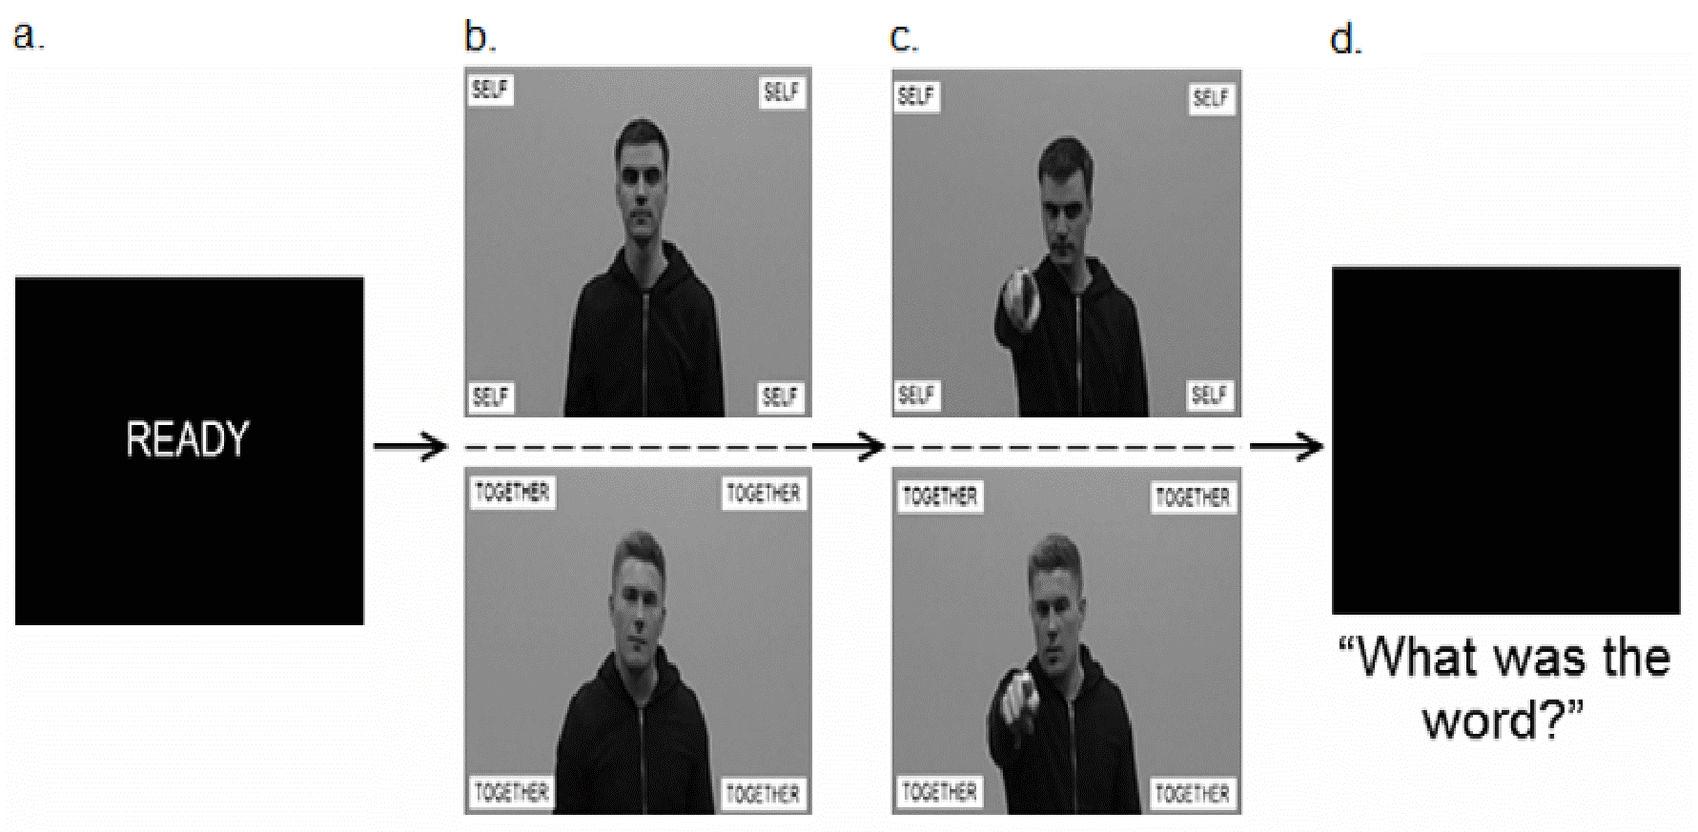
Figure 2.
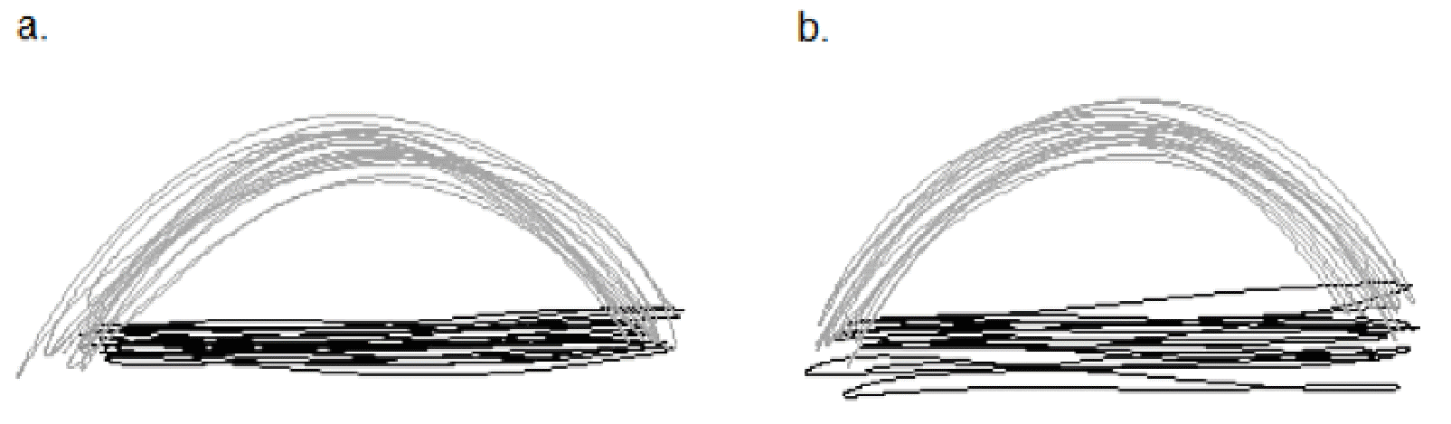
Figure 3.
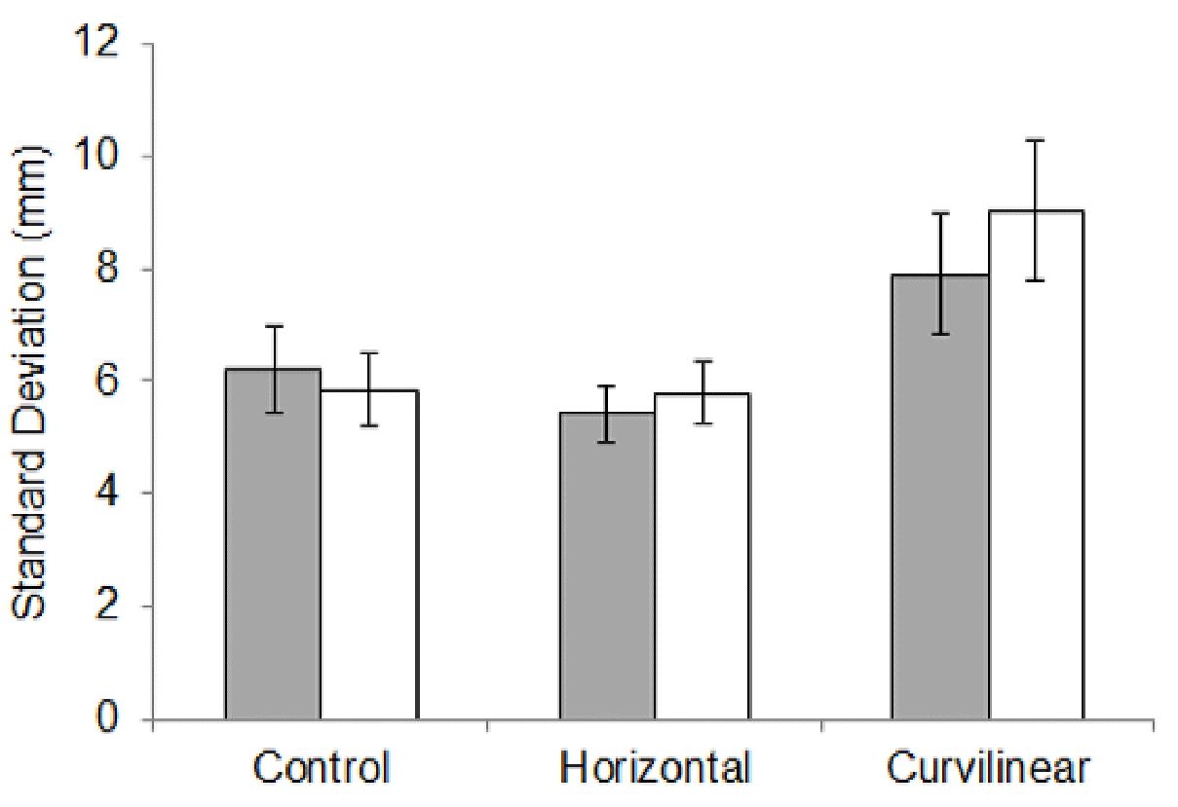
Figure 4.
