Seismic Analysis of a 10 MW Offshore Wind Turbine With a Monopile*

Yang Yang*
School of Energy and Power Engineering
University of Shanghai for Science and Technology
Shanghai，P.R. China
y.yang@ljmu.ac.uk
Chun Li
School of Energy and Power Engineering
University of Shanghai for Science and Technology
Shanghai，P.R. China
lichunusst@163.com

Musa Bashir
Department of Maritime and Mechanical Engineering
Liverpool John Moores University
Liverpool，UK
m.b.bashir@ljmu.ac.uk
Jin Wang
Department of Maritime and Mechanical Engineering
Liverpool John Moores University
Liverpool，UK
j.wang@ljmu.ac.uk

Abstract—With the continued increase in demand for offshore wind energy, larger capacity wind turbines are expected to be installed in areas that are susceptible to damage resulting from local and, potentially, earthquake loadings. Seismic studies on fixed bottom offshore wind turbines (OWTs) have been conducted with the largest capacity up to 5 MW. In order to address the needs for a larger capacity OWT (>5MW), this paper investigates the seismic behavior of the 10 MW reference wind turbine developed by Technical University of Denmark (DTU). A novel seismic analysis framework (SAF) is developed and implemented into the open source tool, FAST, in order to examine the coupled effect of earthquake and wind loadings. The approach used in this study is consistent with the earthquake force calculation method which has successfully been applied in the seismic analysis of building structures. A detailed investigation on the dynamic responses of the DTU 10 MW wind turbine subjected to the 1995 Kobe Japan earthquake event is conducted using SAF. The tower bending moment demand distributed along the tower is presented. In addition, the frequency characteristics of tower top displacements are also identified using the Hilbert Huang transform method. The results indicate that a more robust analysis of 10 MW turbine can be conducted using SAF in comparison to commercial tools.
Keywords—offshore wind turbine, seismic analysis, monopile structure

Introduction
Wind energy is currently playing a leading role in the global production of cleaner energy as an alternative to fossil and non-cleaner fuels. The 2018 Global Wind Energy Council (GWEC) annual wind report, states that 52 GW of newly installed wind capacity was added globally in 2017, and with 50 % of the figure shared by China and the USA [1]. The southeast coastal areas of China and the west coast of the USA, located close to the Pacific seismic belts, are prone to earthquake. Wind turbines installed in these areas are susceptible to damage from the resulting earthquake loading coupled with the local wind loading. Similar circumstances exist for the wind farms located along the southern areas of Europe and New Zealand where there are rich offshore wind resources as presented in Fig. 1 [2]. Therefore, it is imperative to investigate the impacts of earthquake loading on wind turbines due to potential consequences on operation and supply of wind energy in these locations.
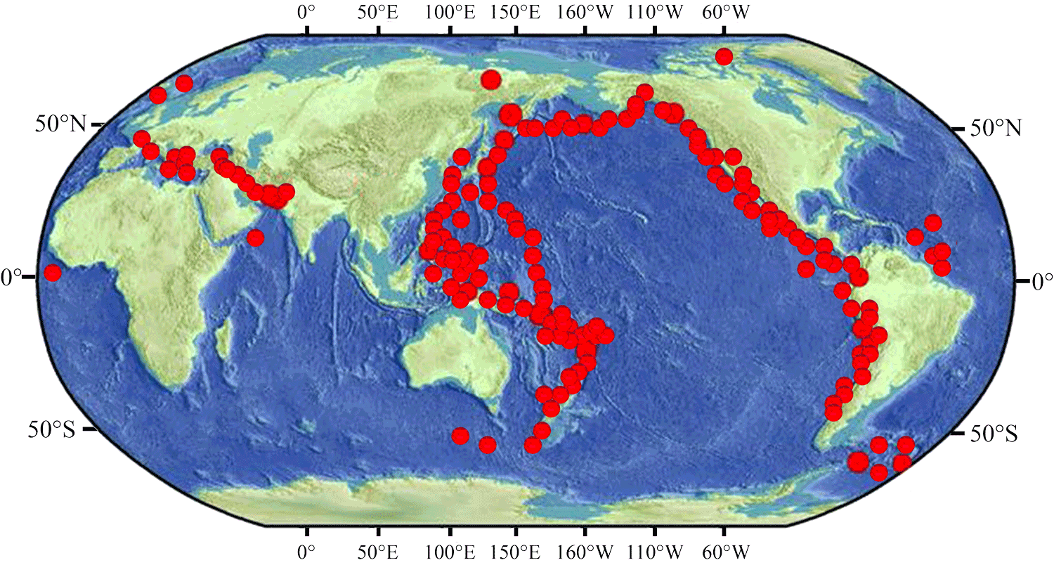
Fig. 1. Global distribution for the more than 300 earthquake events with Richter magnitude values over 6 occurred during 2007~2016.
Santangelo et al. [3] compared the structural responses of coupled and uncoupled time-domain simulations for an offshore wind turbine (OWT) under earthquake loadings. They also investigated the influence of aerodynamic damping. Kim et al. [4] investigated the seismic fragility of a monopile OWT by considering the soil-structure interaction (SSI) effect. The flexible foundation was modelled using a set of lateral springs distributed along the length of the support structure underneath the seabed. The stiffness of each spring at a corresponding depth was represented by a p-y curve. Mo et al. [5] also performed a seismic fragility analysis of an OWT under different operating states by considering the effect of SSI. Wind loads were calculated using FAST and then applied to the FEM model for coupling with earthquake loadings in OpenSees. The probability of reaching damage states was discussed for different wind conditions and earthquake loadings. Alati et al. [6] studied the seismic responses of two bottom-fixed OWTs using GH Bladed. The SSI model was represented by two transitional springs.
Due to the increased demand for the reduction of installation and maintenance costs, the development of larger wind turbines with rated power capacities over 8 MW is receiving significant attentions. However, in all the above mentioned literatures the focus was on the wind turbines whose largest capacity is 5 MW.
Therefore, this study aims to present a preliminary understanding of the seismic impacts on the 10 MW OWTs using a novel seismic analysis framework (SAF) which is developed and implemented into the open source tool, FAST [7]. The uniqueness of SAF made it an essential tool capable of accounting the coupled effect of earthquake and wind loadings. The 10 MW wind turbine developed by Technical University of Denmark (DTU) in collaboration with Vestas is used for the examination model [8]. This study employs the support structure proposed in [9] for the offshore application of the DTU 10 MW wind turbine in 50 m water depth. The International Electrotechnical Commission (IEC) Von Karman turbulent wind spectrum [10] is applied to generate the full-field wind with an average wind speed of 11.4 m/s. The irregular wave with a significant height of 6.0 m and a period of 10.0 s is generated using Airy wave theory and JONSWAP wave spectrum [11]. The 1995 Kobe earthquake event is used to represent the strong ground motion. The structural responses of the DTU 10 MW monopile wind turbine are obtained with the use of SAF. The displacement and bending moment demands of the tower under different loading combinations are compared to illustrate the impacts of the earthquake. Furthermore, the Hilbert Huang Transform (HHT) [12] is applied to obtain time-frequency domain characteristics of the seismic dynamic responses for a better understanding of the seismic influence.

The 10 MW OWT model
DTU and Vestas carried out a design of 10 MW rotor and its corresponding land-based tower for the Light Rotor project [8]. The three-bladed wind turbine has been classed as an IEC class 1A wind climate. The rated power is 10 MW and the rated wind speed is 11.4 m/s. The original tower was designed for the land-based type. However, in order to meet the structural strength requirements of OWTs installed in 50 m water depth areas used in this study, the diameter and thickness of the tower are scaled with factors of 1.20 and 1.37, respectively [9]. The modified tower diameters at top and base are 6.5 m and 10 m, and the thicknesses at top and base are 25 mm and 52 mm. A summary of the main specifications of the 10 MW OWT for 50 water depth is presented in Table 1.
Table 1: Main specifications of the tower-scaled DTU 10 MW reference wind turbine
Property (Unit) | Value
Rated power (MW) | 10.0
Rated wind speed (m/s) | 11.4
Cut-in speed (m/s) | 4.0
Cut-out speed (m/s) | 25.0
Rotor speed range (rpm) | 6 ~ 9.6
Rotor diameter (m) | 178.3
Hub diameter (m) | 5.6
Gearbox ratio (-) | 50
Shaft tilt angle (degrees) | 5.0
Rotor pre-cone angle (degrees) | -2.5
Rotor mass (kg) | 227,962
Nacelle mass (kg) | 446,036
Hub height (m) | 129.0
Tower length (m) | 116.53
Distance from the transition piece to mean sea level (m) | 10.0
Tower-top diameter (m) | 6.5
Tower-base diameter (m) | 10
Tower-top thickness (mm) | 25
Tower-base thickness (mm) | 52

Development of SAF
In order to accurately model the combined effects of turbulent wind, irregular wave and earthquake effects on the OWT, a user-compiled module is developed and integrated into an open source code numerical tool, FAST. This newly developed tool makes it possible for accurate simulations of OWT subjected to earthquake loadings, SSI and environment conditions (wind, wave and current) to be made using FAST for the first time.
The SAF is developed as a user-compiled tool following the integration of the newly developed QuakeDyn module into FAST in order to provide the seismic analysis capability. The earthquake force acting on the wind turbine is calculated based on the normalized mode shapes of the support structure and input accelerograms.
In the QuakeDyn module, the basis for the calculation of the earthquake loads acting on the support structure is the generic method that is widely used in the seismic analysis of buildings. The earthquake force associated with each mode of the support structure,, is derived as:
(1)
where is the horizontal acceleration of input ground motion. and are the mass density and the ith normalized mode shape of the support structure, respectively. H is the length of the support structure.
The rotor and nacelle are treated as a lumped mass on the top of the support structure. The earthquake force acting on the tower-top components, , is derived as:
(2)
where is the sum of the rotor and nacelle masses.
The vertical earthquake force of the whole wind turbine, , is applied at the base of the support structure and calculated as follows:
(3)
where is the vertical acceleration of the input ground motion. is the mass of the whole wind turbine.
The earthquake loads are added into the active force component of the equation of motion established in FAST [7]. Therefore, the earthquake loads are combined with other environmental loads, including aerodynamic loads, hydrodynamic loads and gravitational force, in order to perform the nonlinear SSI-coupled dynamic simulations.

Environmental loadings

Wind Loading
Von Karman wind spectrum is used for the full-field turbulent wind generation. According to the IEC specifications, the power spectral density (PSD) associated with each direction is defined as follows:
(4)
(5)
where is the PSD of the inflow direction. is the PSD of the lateral and vertical directions. f is the frequency. L is the Monin-Obukhov length representing the buoyancy impact on turbulence. is the average wind speed at the hub height, the value is 11.4 m/s in this study. is the standard deviation equal to the ratio of turbulence intensity by the wind speed. The turbulence intensity adopted in this paper is 12 %.
Fig. 3 presents the time-varying wind speeds at the hub in the three directions.
Fig. 3. Wind speed at the hub

Wave Loading
The wave histories are generated using the Airy wave theory. The wave time histories can be written as follows:
(6)
(7)
(8)
(9)
where is the wave elevation time history. is the wave frequency in rad/s. is the PSD at . is a random phase angle falling within 0 to . is the water depth. z is the local water depth. k is the wave number related with z and as expressed in Eq. (10).
(10)
where g is the gravitational acceleration.
The PSD of wave spectrum is defined using JONSWAP spectrum denoted as follows:
(11)
(12)
where is the generalized Philip parameter equal to . is the wave angular frequency equal to . is the wave period, the adopted value in this paper is 10 s. is the significant height of the wave, the value adopted herein is 6 m. is 0.07 when and it is 0.09 when. is the peakedness parameter selected in terms of:
(13)
The wave elevation with a significant height of 6m and a wave period of 10 s is presented in Fig. 4.
Fig. 4. Wave elevation

Earthquake Loading
The 1995 Kobe earthquake record with a peak ground acceleration of 0.232 g is selected as the input ground motion. The earthquake excitation is added into the simulation with a duration of 600s in the 400th s. The ground accelerations in the translational directions are presented in the Fig. 5.
Fig. 5. Ground accelerations of the 1995 Kobe earthquake event

Results and discussions
With the use of SAF, the dynamic responses of the DTU 10 MW OWT subjected to multiple hazards associated with turbulent wind, irregular wave and earthquake event are obtained. Fig.6 presents the time-varying tower base bending moments and tower top displacements. The out-of-plane (fore-aft) bending moment at tower base is enhanced slightly by the earthquake loading. The maximum amplitude increases to 675 MN·m from 656 MN·m. Meanwhile, a 9.6% increase caused by the earthquake loading is observed regarding the maximum fore-aft tower top displacement. However, the in-plane (side-side) responses are enhanced significantly by the earthquake loading due to the absence of aerodynamic loads. More specifically, the maximum in-plane bending moment at the tower base is increased from 36.7 MN·m to 631 MN·m. The side-side tower top displacement is enhanced from 0.067 m to 0.872 m. It is notable that the in-plane responses caused by the earthquake loading are in equivalent levels with out-of-plane responses dominated by the wind loading. It means that the earthquake loading has equivalent contributions to the resultant responses of the wind turbine. These observations also indicate that the wind loading plays a dominant role for the out-of-plane responses of the 10 MW wind turbine, while the in-plane responses are dominant by the earthquake loading.
(a) Tower base bending moments

(b) Tower top displacements
Fig. 4. The dynamic responses of the DTU 10 MW OWT subjected to an earthquake event
The distributions of maximum displacement and bending moment along the tower height are presented in Fig. 5. The earthquake results in a larger deformation of the tower above 40m. Due to the earthquake contribution in side-side direction, a 45.5% enhancement of the resultant displacement at tower top is observed. Regarding the maximum tower bending moment, the value at the tower base is slightly increased by the earthquake loading, while significant increments can be observed for the portion close to the mean sea level (MSL). The maximum discrepancy between the results with and without earthquake influence is around 52.6 % at the MSL. These observations indicate that the amplitude of the side-side vibration induced by the earthquake loading is equivalent with the deformation caused by the wind loading. The aerodynamic loads of the design condition has a dominant contribution to the bending moment at the tower base, while the earthquake has significant influence on the structural responses at the portion close to the MSL.
Fig. 5. Maximum displacement and bending moment distributions along with the tower height
The time-frequency spectra of the tower top displacement in the fore-aft direction are presented in Fig. 6. The color represents the magnitude of the response at the corresponding frequency and time. It can be observed that the response close to the 1st fore-aft eigen-frequency (0.27 Hz) is enhanced significantly after the occurrence of the earthquake (> 400 s). There is no notable difference can be observed at the frequency close to the 2nd fore-aft eigen-frequency (1.76 Hz). It means the higher order mode has not been activated by the earthquake loading. The majority of the responses still comes from the 1st eigenmode.
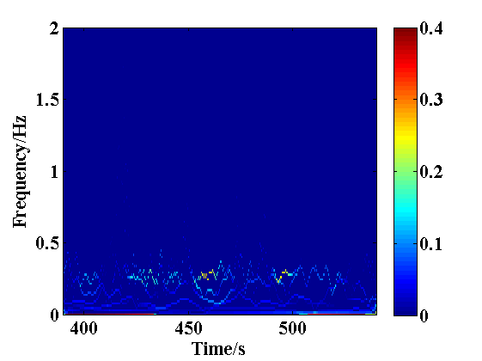
(a) With earthquake
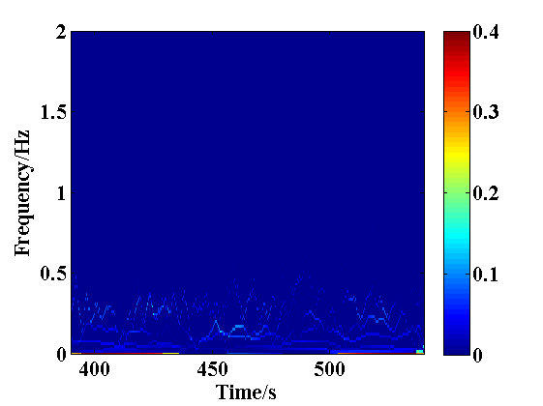
(b) Without earthquake
Fig. 6. The time-frequency spectra of the tower top displacement

Conclusions
In order to address the research gap of seismic analysis for 10 MW OWTs, this study has developed a novel and generic tool (SAF) based on FAST, in order to conduct accurate simulations for OWTs. The structural responses of the DTU 10 MW wind turbine in 50 m water depth under multiple hazards are calculated with the use of SAF. The 1995 Kobe earthquake was used for the investigation and it has been found that the seismic loads have a weak influence on the out-of-plane bending moment at the tower base, while the in-plane responses are influenced significantly by the earthquake. A 45.5% increase of the resultant tower top displacement is observed due to the severe vibration in the side-side direction induced by the earthquake. Moreover, the bending moments of the tower close to the MSL are increased significantly. The responses at the 1st eigen-frequency are enhanced by the earthquake, while the earthquake has invisible impacts on the 2nd eigen-frequency responses.

Acknowledgment
The authors would like to acknowledge the financial support of European Union H2020 research program (RESET, project ID: 730888), National Natural Science Foundation of China (grant numbers: 51676131 and 51811530315) and Royal Society (grant number: IEC\NSFC\170054). The first author is particularly grateful to Chinese Scholarship Council for funding his overseas study in the UK (grant number: 201708310149).

References
- GWEC, Global Wind Energy Council. "Global Wind Report: Annual Market Update 2017."http://gwec.net/cost-competitiveness-puts-wind-in-front/.[Accessed May 18, 2018] (2018).
- China Earthquake Networks Center. http: //www.ceic.ac.cn/.
- F. Santangelo, G. Failla, ,F. Arena & C. Ruzzo. On time-domain uncoupled analyses for offshore wind turbines under seismic loads.” Bulletin of Earthquake Engineering, vol. 16(2), 2018,pp. 1007–1040.
- G. L. Sang and H. K. Dong. "Seismic fragility analysis of 5 MW offshore wind turbine." Renewable Energy, vol. 65.5(2014), 2014, pp. 250-256.
- R. Mo, H. Kang, M. Li, and X. Zhao. "Seismic fragility analysis of monopile offshore wind turbines under different operational conditions". Energies, vol. 10(7), 2017, pp.1037.
- N. Alati, G. Failla and F. Arena. "Seismic analysis of offshore wind turbines on bottom-fixed support structures." Philosophical Transactions of the Royal Society A, vol. 373(2035), 2015.
- J. M. Jonkman. Modeling of the UAE wind turbine for refinement of FAST_AD. (No. NREL/TP-500-34755). National Renewable Energy Laboratory. Golden, CO (US), 2003.
- C. Bak, R. Bitsche, A. Yde, T. Kim, M. H. Hansen, F. Zahle, et al. "Light Rotor: The 10-MW Reference Wind Turbine", Proceedings of the European Wind Energy Association (EWEA) Annual Event, Copenhagen, pp. 16-19.
- J. Velarde. "Design of Monopile Foundations to Support the DTU 10 MW Offshore Wind Turbine", Master thesis, Norwegian University of Science and Technology.
- B. J. Jonkman. “TurbSim user's guide: Version 1.50”. National Renewable Energy Laboratory, Technical Report No. NREL/TP-500-46198, 2009.
- C. Sun. “Semi-active control of monopile offshore wind turbines under multi-hazards”. Mechanical Systems and Signal Processing, 99, 2018, pp.285-305.
- N. E. Huang, Z. Shen, S. R. Long, M. C Wu, H. H Shih and Q. Zheng, et al. "The empirical mode decomposition and the Hilbert spectrum for nonlinear and non-stationary time series analysis." In Proceedings of the Royal Society of London A: mathematical, physical and engineering sciences. Vol. 454, 1998, pp. 903-995.

